Project Design Phase
Solution Architecture

Date | 15 February 2025
Team ID | Not specified in project brief
Project Name | Auto Ticket Classification using Flow Designer
Maximum Marks | 4 Marks

Solution Architecture: ServiceNow School IT Ticket Automation
The architecture bridges the school helpdesk problem and a maintainable ServiceNow solution. It uses a ticket form, Incident Workflow data, Flow Designer keyword logic, dependent choices, and email notification.
- Find a platform-native solution that reduces manual categorization.
- Describe the record, flow, data, and user interactions for project stakeholders.
- Define the features and configuration needed for the first release.
- Provide implementation specifications for a secure, reusable, and scalable no-code workflow.

Project Solution Architecture Diagram:

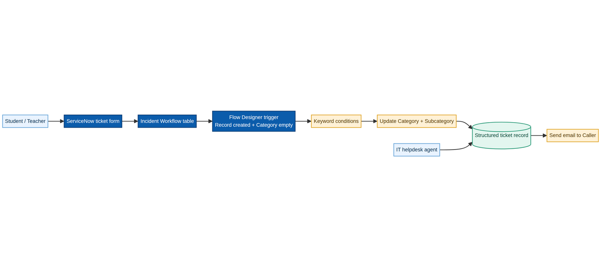
Figure 1: Architecture and data flow of the school IT ticket classification solution
Source: Auto Ticket Classification using Flow Designer project brief

